CM2102 – Database Systems

Coursework 2 – SQL Queries - C1722325

1.  
Query

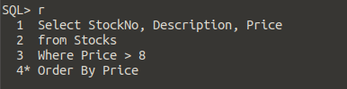

Result

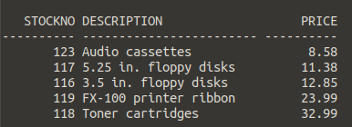

2.  
Query

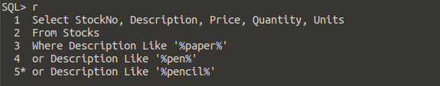

Result

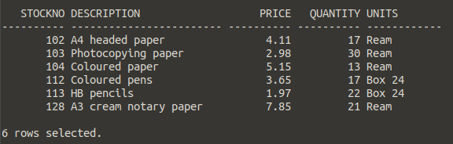

3.  
Query

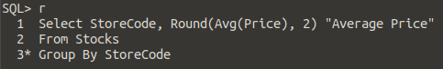

Result

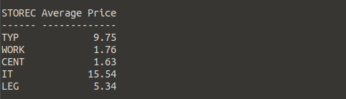

4.  
Query

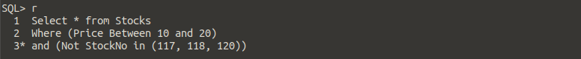

Result



5.  
Query

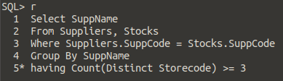

Result

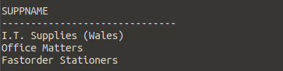

6.  
Query

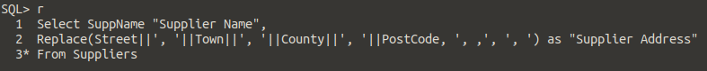

Result

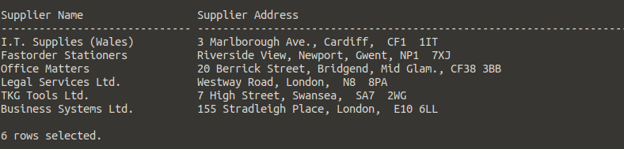

7.  
Query

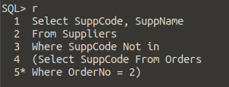

Result

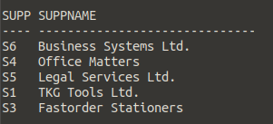

8.  
Query

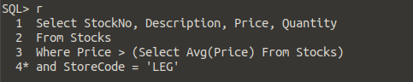

Result

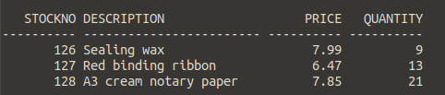

9.  
Query

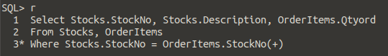

Result

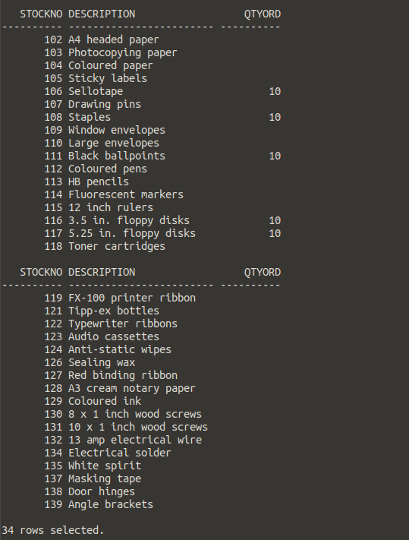

10.  
Query

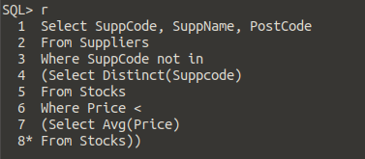

Result

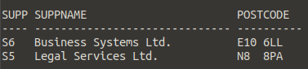

11.  
Report Command

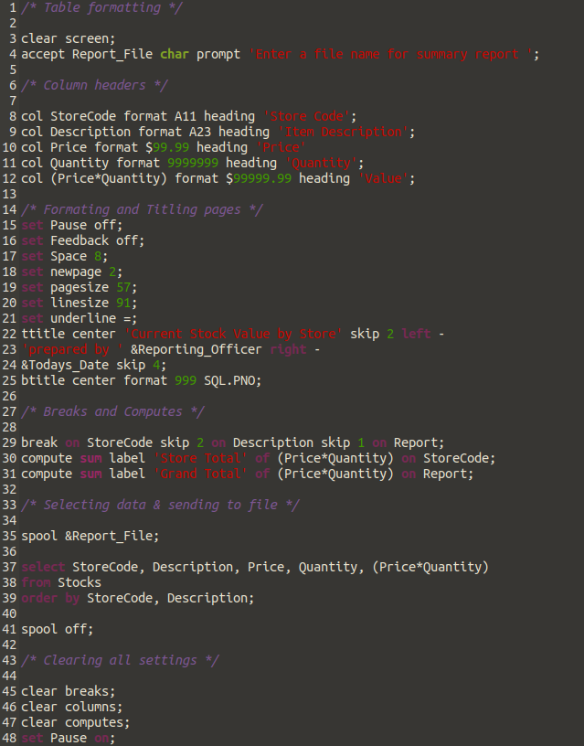

Result

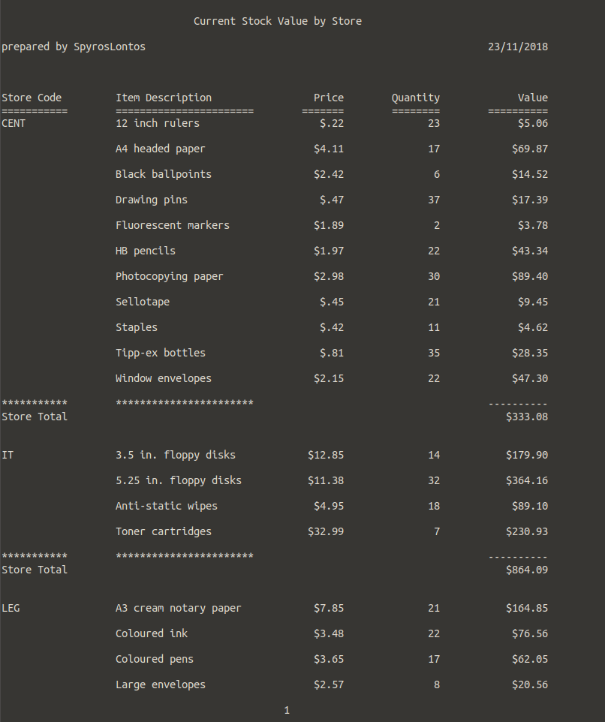

(Continuing on next page)

